**Create table queries**: **→**

mysql> create table supplier(

-> ssup_id int primary key,

-> ssup_name varchar(10),

-> ssup_city varchar(10),

-> ssup_phone int(10));

Query OK, 0 rows affected, 1 warning (0.03 sec)

mysql> create table customer(

-> cus_id int primary key,

-> cus_name varchar(10),

-> cus_phone int(10),

-> cus_city varchar(10),

-> cus_gender char(1));

Query OK, 0 rows affected, 1 warning (0.03 sec)

mysql> create table category(

-> cat_id int primary key,

-> cat_name varchar(10));

Query OK, 0 rows affected (0.02 sec)

mysql> create table product(

-> pro_id int primary key,

-> pro_name varchar(10),

-> pro_desc varchar(10),

-> cat_id int,

-> foreign key(cat_id) references category(cat_id));

Query OK, 0 rows affected (0.02 sec)

mysql> create table productdetails(

-> prod_id int primary key,

-> pro_id int,

-> foreign key(pro_id) references product(pro_id),

-> ssup_id int,

-> foreign key(ssup_id) references supplier(ssup_id),

-> price int(5));

Query OK, 0 rows affected, 1 warning (0.03 sec)

mysql> create table eorder(

-> ord_id int primary key,

-> ord_amount int(10),

-> ord_date date,

-> cus_id int,

-> foreign key(cus_id) references customer(cus_id),

-> prod_id int,

-> foreign key(prod_id) references productdetails(prod_id));

Query OK, 0 rows affected, 1 warning (0.03 sec)

mysql> create table rating(

-> rat_id int primary key,

-> cus_id int,

-> foreign key(cus_id) references customer(cus_id),

-> ssup_id int,

-> foreign key(ssup_id) references supplier(ssup_id),

-> rat_ratstars int(2));

Query OK, 0 rows affected, 1 warning (0.02 sec)

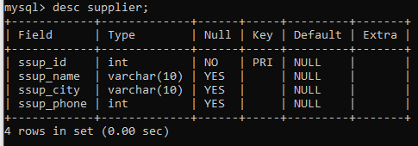

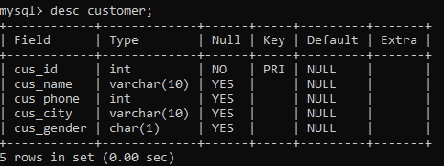

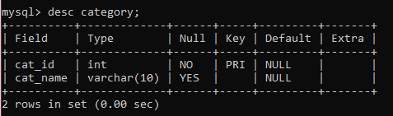

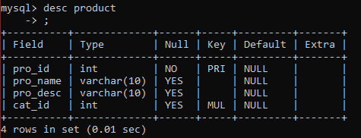

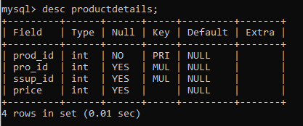

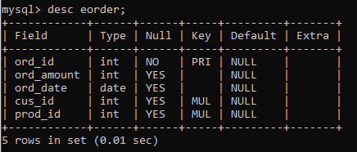

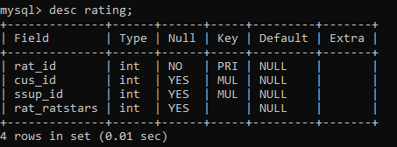

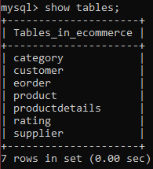

**Insert values into table queries**: **→**

insert into ecommerce.supplier values(1, "Rajesh", "Delhi", 1234567890);

insert into ecommerce.supplier values(2, "Appario", "Mumbai", 258963147);

insert into ecommerce.supplier values(3, "Knome pro", "Banglore", 978546231);

insert into ecommerce.supplier values(4, "Bansal Rt", "Kochi", 897546328);

insert into ecommerce.supplier values(5, "Mittal Ltd", "Lucknow", 789845653);

insert into ecommerce.customer values(1, "AAKASH", 999999999, "DELHI", 'M');

insert into ecommerce.customer values(2, "AMAN", 978546321, "NOIDA", 'M');

insert into ecommerce.customer values(3, "NEHA", 999999999, "MUMBAI", 'F');

insert into ecommerce.customer values(4, "MEGHA", 999456239, "KOLKATA", 'F');

insert into ecommerce.customer values(5, "PULKIT", 789599999, "LUCKNOW", 'M');

insert into ecommerce.category values(1, "Books")**;**

insert into ecommerce.category values(2, "Games");

insert into ecommerce.category values(3, "GROCERIES");

insert into ecommerce.category values(4, "ELECTRONIC");

insert into ecommerce.category values(5, "CLOTHES");

insert into ecommerce.product values(1, "GTA V", "asdasdasd", 2);

insert into ecommerce.product values(2, "T SHIRT", "JHGJGHJFGH", 5);

insert into ecommerce.product values(3, "LAPTOP", "EHRWWBRNBR", 4);

insert into ecommerce.product values(4, "oats", "jksdfsndft", 3);

insert into ecommerce.product values(5, "HARRY POT.", "MXCVCXMEM", 1);

insert into ecommerce.productdetails values(1, 1, 2, 1500);

insert into ecommerce.productdetails values(2, 3, 5, 30000);

insert into ecommerce.productdetails values(3, 5, 1, 3000);

insert into ecommerce.productdetails values(4, 2, 3, 2500);

insert into ecommerce.productdetails values(5, 4, 1, 1000);

insert into ecommerce.eorder values(20, 1500, '2021-10-12', 3, 5);

insert into ecommerce.eorder values(25, 30500, '2021-09-16', 5, 2);

insert into ecommerce.eorder values(26, 2000, '2021-10-05', 1, 1);

insert into ecommerce.eorder values(30, 3500, '2021-08-16', 4, 3);

insert into ecommerce.eorder values(50, 2000, '2021-10-06', 2, 1);

insert into ecommerce.rating values(1, 2, 2, 4);

insert into ecommerce.rating values(2, 3, 4, 3);

insert into ecommerce.rating values(3, 5, 1, 5);

insert into ecommerce.rating values(4, 1, 3, 2);

insert into ecommerce.rating values(5, 4, 5, 4);

**Queries: →**

1. select c.cus_id, c.cus_name, c.cus_phone, c.cus_gender, e.ord_id, e.ord_amount, e.ord_date

from ecommerce.customer c

join ecommerce.eorder e on e.cus_id = c.cus_id

where e.ord_amount>=3000

group by c.cus_gender;



1. select e.ord_id, e.ord_amount, e.ord_date, c.cus_id, c.cus_name, c.cus_phone, c.cus_city, pd.price, p.pro_name, p.pro_desc

from ecommerce.eorder e

join ecommerce.customer c on c.cus_id = e.cus_id

join ecommerce.productdetails pd on pd.prod_id = e.prod_id

join ecommerce.product p on p.pro_id = pd.pro_id

where c.cus_id=2;



1. select s.*

from ecommerce.supplier s

join ecommerce.productdetails pd on pd.ssup_id = s.ssup_id

having count(pd.pro_id)>1



1. select cat_name, pro_name, price, ord_amount, ord_date

from ecommerce.category c

join ecommerce.product p on p.cat_id = c.cat_id

join ecommerce.productdetails pd on pd.pro_id = p.pro_id

join ecommerce.eorder e on e.prod_id = pd.prod_id

where e.ord_amount<2000



1. select p.pro_id, p.pro_name

from ecommerce.product p

join ecommerce.productdetails pd on pd.pro_id = p.pro_id

join ecommerce.eorder e on e.prod_id = pd.prod_id

where e.ord_date>'2021-10-05'

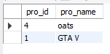

1. select cus_name, cus_gender

from ecommerce.customer c

where c.cus_name like '%A' or c.cus_name like 'A%'

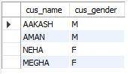

1. DELIMITER //

CREATE PROCEDURE SupplierRating()

BEGIN

select s.ssup_id, s.ssup_name, r.rat_ratstars,

case

when r.rat_ratstars > 4 then "Geniune Supplier"

when r.rat_ratstars > 2 then "Average Supplier"

else "Supplier should not be considered"

END as 'RatingTest'

from

supplier s

join rating r on r.ssup_id = s.ssup_id;

END//

DELIMITER ;

